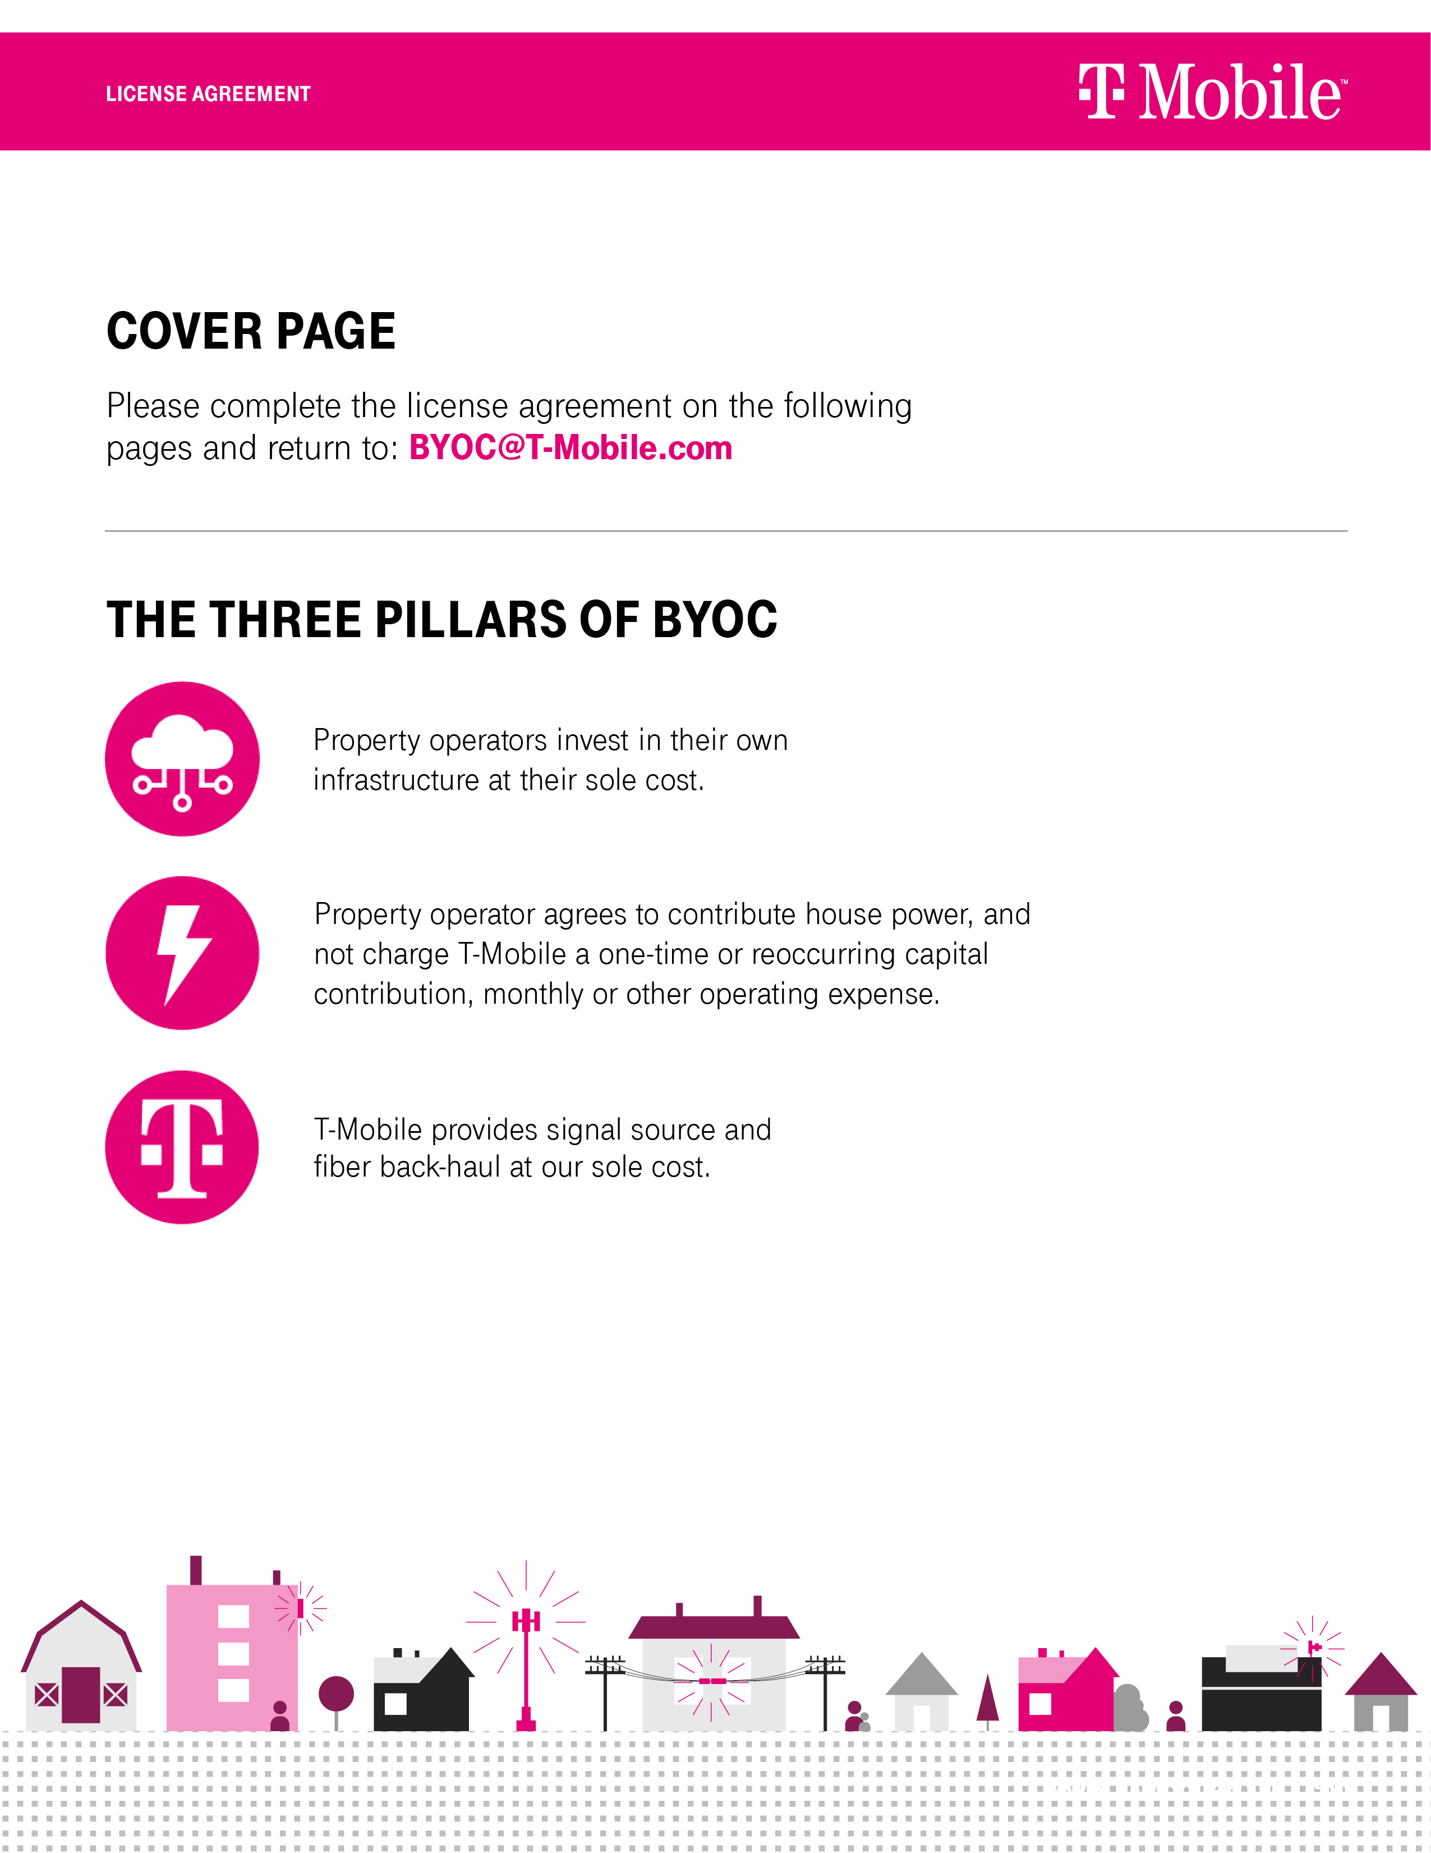

DAS LICENSE AGREEMENT

This DAS License Agreement (“Agreement”), dated as of the latter of the signature dates below (the “Effective Date”), is made and entered into by and between ________________ (“Owner”) and T-Mobile _____ LLC, a Delaware limited liability company (“Provider”). Each of Owner and Provider may be referred to as a “Party” and collectively as the “Parties”.
WHEREAS, Owner holds leasehold or ownership rights in and to the venue commonly referred to as _____________, which is located at _______________ (collectively, the “Property”); and
WHEREAS, Owner has installed and currently operates a distributed antenna system (“DAS”) on the Property; and
WHEREAS, Provider is in the business of providing wireless telecommunications services and Owner desires that Provider connect its equipment to the DAS to facilitate the provision of such services to Provider’s customers and patrons of the Property.
NOW THEREFORE, for and in consideration of the mutual covenants and agreements contained herein and other valuable consideration, the receipt and sufficiency of which are hereby acknowledged, Owner and Provider agree as follows:
ARTICLE 1 – LICENSE
  - Grant of License. Owner hereby grants to Provider a license to (a) use certain spaces on and within the Property (such spaces being referred to as the “Premises”), as initially set forth on Exhibit A, necessary to design, install, operate, maintain, upgrade, inspect, replace and repair the equipment, lines, cables and related components (collectively, the “Provider’s Equipment”) that will be connected to the DAS, and (b) connect the Provider’s Equipment to the DAS to provide wireless services to Provider’s customers and patrons of the Property. Provider shall also have reasonable access to, over and across portions of the Property to enable Provider to exercise its rights and obligations hereunder, including ingress, egress and telecommunication and utility connections to and from the Provider’s Equipment. To support the operation of the Provider’s Equipment, Provider shall have the right to install, operate, maintain, upgrade, inspect, replace and repair telecommunications equipment on the roof of the Property, including, without limitation, microwave dishes and related equipment, and any such rooftop space utilized by Provider shall for all purposes be deemed to be part of the Premises.

  - Access. Owner shall provide Provider, its employees, agents and contractors reasonable access to the Premises during the Term (as defined below), at reasonable times to conduct the activities permitted herein. In the event of an emergency, Provider shall have access to the Premises 24 hours per day, 7 days per week. In order to obtain access to the Premises during off hours when a representative of Owner is not available, Provider shall contact ___________________ at ___________________.

  - No Interference with Owner Operations. Construction of the Provider’s Equipment shall be done in a manner which does not unreasonably interfere with the operations of Owner.

  - Representations and Warranties. Owner represents and warrants to Provider that: (a) Owner owns or leases the Premises; (b) Owner has the right to enter into this Agreement; (c) execution of this Agreement and the installation of Provider’s Equipment does not violate the terms of any agreements or policies regarding the Property; and (d) all consents or approvals for the installation and operation of Provider’s Equipment have been obtained.

  - Removal of Provider’s Equipment. Within sixty (60) days after the expiration or earlier termination of this Agreement, Provider, at its sole cost, shall remove the Provider’s Equipment and repair any damage caused by such removal, ordinary wear and tear excepted.

ARTICLE 2 – TERM

  - Term. The initial term of this Agreement is ten (10) years (the “Initial Term”) and shall commence on the date that the Provider’s Equipment is made operational for commercial use (the “Commencement Date”), which date shall be confirmed by a notice from Provider to Owner.

  - Renewal Terms. The Agreement shall automatically renew for twenty (20) additional and successive one (1) year terms (each, a “Renewal Term”) unless Provider elects not to renew by providing written notice to Owner before the end of the then current Term. The Initial Term plus any Renewal Terms utilized by Provider shall be referred to as the “Term”.

ARTICLE 3 – RESERVED

ARTICLE 4 – PROVIDER’S EQUIPMENT AND OWNERSHIP OF DAS

  - Utilities. Provider shall have the right to connect Provider’s Equipment to an existing source of electrical power at the Property, and the cost for such power usage shall be borne solely by Owner. At its sole cost and expense, Provider shall have the right to connect the Provider’s Equipment to existing optical fiber facilities on the Property, or install new optical fiber or microwave facilities on the Property to serve the Provider’s Equipment. Owner shall reasonably cooperate with Provider’s efforts to obtain all necessary utilities necessary for the operation of the Provider’s Equipment.

  - Ownership and Maintenance of DAS. The DAS shall remain the personal property of Owner, owned and controlled by Owner at all times. At its sole cost and expense, Owner shall be responsible for the operation, maintenance, monitoring and repair of the DAS.

  - Construction. Before installing the Provider’s Equipment, Provider will obtain Owner’s prior written approval of the construction drawings for such installation, which approval will not be unreasonably withheld, conditioned or delayed, and Owner’s approval is deemed given as to the construction drawings attached as Exhibit A. Provider will also obtain any other necessary governmental permits or approvals required for the installation and operation of the Provider’s Equipment. After the initial installation of the Provider’s Equipment, Provider may add to, upgrade or otherwise modify the Provider’s Equipment, including, without limitation, the utilization of additional technologies or frequencies, without Owner’s consent as long as such actions do not increase the dimensions of the Premises.

  - Provider’s Frequencies. Pursuant to one or more licenses acquired from the Federal Communications Commission (“FCC”), Provider (directly, or through an affiliate) owns the sole and exclusive right to utilize the frequencies to be broadcast through Provider’s Equipment. The Parties agree that Owner does not have, and will not acquire through this Agreement, any proprietary or ownership rights or interest in Provider’s frequencies, network, cell sites and related components, or the public revenues associated with the services provided by Provider. Provider shall at all times have the unfettered right to control the operation of Provider’s frequencies, including, but not limited to, the right to instruct Owner to immediately cease using the frequencies at any time for any reason.

  - Confidentiality. Notwithstanding anything to the contrary in this Agreement, unless pre-approved by the other Party in writing, neither Party shall disclose any information of any type relating to the operation and performance of the DAS or Provider’s Equipment, including, without limitation, information regarding system availability, coverage area, call statistics, data usage and data speeds, and all such information shall be deemed to be confidential (“Confidential Information”). Each Party will be responsible for any improper use or disclosure of any Confidential Information of the other by the receiving Party’s officers, partners, principals, employees, agents or independent contractors.

ARTICLE 5 – ENVIRONMENTAL

  - Pre-Existing Conditions. Provider shall have no responsibility for environmental conditions existing within the Premises prior to the Effective Date or any environmental conditions not arising out of the use and occupancy of the Premises by Provider.

  - Environmental Indemnity. As between Owner and Provider, Owner is responsible for the identification, investigation, monitoring and remediation and cleanup of any substances brought onto the Property that are identified by any law, ordinance or regulation as hazardous, toxic or dangerous (collectively, the “Hazardous Substances”) discovered on the Property and agrees to indemnify, defend, and hold harmless Provider from and against any and all claims relating to the Hazardous Substances on or affecting the Property, unless the presence of the Hazardous Substances results from Provider’s activities. Provider will not introduce or use any Hazardous Substances at the Premises or on the Property in violation of any applicable law and Provider will indemnify, defend and hold harmless Owner from and against any and all claims arising out of Provider’s breach of this provision. The indemnity obligations under this Paragraph will survive the termination or expiration of this Agreement.

ARTICLE 6 – INSURANCE AND INDEMNIFICATION

  - Insurance.
Provider and Owner shall, as applicable, maintain the following insurance coverage in full force during the Term of this Agreement:
- Commercial General Liability Insurance.
Provider shall carry commercial general liability insurance covering all operations by or on behalf of Provider for personal injury and damage to property (including the loss of use thereof), including broad form property damage and explosion, collapse and underground hazards, and products and completed operations coverage. Limits of liability shall not be in amounts less than One Million Dollars ($1,000,000) per occurrence and Two Million Dollars ($2,000,000) general aggregate. The general aggregate limit shall apply on a per location and per project basis. Owner shall be included as an additional insured.
- Workers’ Compensation and Employer’s Liability Insurance.
Provider shall maintain workers’ compensation insurance as mandated by state law where the Property is located for all Provider employees. Provider shall maintain employer’s liability insurance in an amount not less than One Million Dollars ($1,000,000).
- Automobile Insurance.
Provider shall maintain commercial automobile liability insurance, including coverage for all owned, hired and non-owned automobiles. The amount of coverage shall not be less than One Million Dollars ($1,000,000) combined single limit for each accident and for bodily injury and property damage.
- Commercial Property and Builder’s Risk Insurance.
Provider shall carry “all risks” or “special causes of loss” property insurance on its personal property, including but not limited to the Provider’s Equipment, in an amount sufficient to repair or replace such property.
- Umbrella Insurance.
Provider shall maintain an umbrella insurance policy providing coverage in excess of its primary commercial general liability, automobile liability and employer’s liability policies in an amount not less than Five Million Dollars ($5,000,000) per occurrence and Five Million Dollars ($5,000,000) general aggregate. The general aggregate limit shall apply on a per location and per project basis. Owner shall be included as an additional insured.
- Certificates of Insurance.
Certificates of insurance, as evidence of the insurance required by this Agreement, shall be furnished by Provider to Owner before any access to the Property or construction is commenced by Provider, its agents or contractors. The policies required herein will be endorsed to include a thirty (30) days’ notice prior to cancellation to the additional insured referenced herein and copies of said endorsements shall be attached to the certificates of insurance.
- Owner Insurance.
Owner shall maintain commercial general liability insurance covering the Property in an amount of not less than Two Million Dollars ($2,000,000), commercial property insurance covering the Property and an umbrella insurance policy with the coverage set forth in Subsection 6.1(e) above. Owner shall also carry “all risks” or “special causes of loss” property insurance on its personal property, including but not limited to the DAS, in an amount sufficient to repair or replace such property.
- Insurer Qualifications.
All of the above-required insurance coverages/policies shall be written by insurance companies licensed to issue policies in the state where the Property is located and with an A.M Best rating of no less than A-.
- Waiver of Subrogation.
Owner and Provider hereby mutually release each other (and their directors, officers, employees, agents, successors or assigns) from liability and waive all right of recovery against the other for any loss or damage; (i) covered by their respective first party property insurance policies for all perils insured there under, (ii) within any deductible or self-insured retention, or (iii) in excess of the applicable limits of such policy or policies, it being the intent of the Parties that each shall look solely to its own insurance to protect itself from loss to its own property. In the event of such insured loss, neither Party’s insurance company shall have a subrogated claim against the other.
  - Indemnification. Owner and Provider shall each indemnify, defend, and hold the other harmless from and against any claim of liability or loss, including reasonable attorneys’ fees, from personal injury, property damage, or other liability resulting from or arising out of the negligence or willful misconduct of the indemnifying Party or its employees, contractors or agents, except to the extent such claims or damage may be due to or caused by the negligence or willful misconduct of the indemnified Party or its employees, contractors or agents. The indemnity obligations under this paragraph will survive the termination or expiration of this Agreement.

ARTICLE 7 – ASSIGNMENT

This Agreement may be assigned by Provider without Owner’s consent to any parent, affiliate or subsidiary of Provider, any party that merges or consolidates with Provider or its parent, or any party that purchases or otherwise acquires a majority of Provider’s ownership interest or assets in the FCC market in which the Property is located. Any other assignment of this Agreement by Provider will require Owner’s prior written consent, which consent shall not be unreasonably withheld, conditioned or delayed.

ARTICLE 8 – DEFAULT

Each of the following events shall constitute an “Event of Default” under this Agreement:

  - If Provider fails to pay any scheduled payments due under the Agreement within 15 days after receiving written notice of such failure from Owner; or

  - If either Party defaults in the performance of any of its covenants or obligations hereunder and such default continues for a period of thirty (30) days after written notice thereof from the non-defaulting Party (unless the nature of the event takes longer to cure and the defaulting Party commences a cure within the time period and diligently pursues it thereafter), the non-defaulting Party may thereafter terminate this Agreement upon written notice to the defaulting Party. In addition, if an Event of Default is not cured as provided herein, the non-defaulting Party may pursue any other available remedies at law or in equity.

ARTICLE 9 – TERMINATION

  - Provider may terminate this Agreement immediately upon written notice to the Owner if Provider fails to obtain all necessary permits or other approvals required from any governmental authority, or any easements required from any third party to operate the DAS on the Premises, or if any such approval is canceled, expires or is withdrawn or terminated.

ARTICLE 10 – NO INTERFERENCE

Owner represents that it will utilize good faith efforts to eliminate any interference from any other source if such interference is affecting the DAS.

ARTICLE 11 –CASUALTY AND CONDEMNATION

  - Separate Claims and Continued Operations. In any condemnation proceeding, Owner and Provider shall have the right to present separate claims for their respective interest in the award or portions of any potential condemnation award. Each Party shall immediately notify the other of any notice regarding an actual or potential condemnation or taking of the Property or Premises. In the event of a partial condemnation, Owner and Provider shall work together in good faith to develop a continuation of operations plan that provides for the continued operation of the DAS in all then surviving portions of the Property, including plans for any additional installations required to continue operations.

  - Condemnation or Casualty. If (a) a condemnation of the Property or the Premises by a governmental authority or (b) total or partial damage or destruction of the Property or the Premises, in either event to an extent that precludes or prohibits Provider from using the Premises for the purposes contemplated in this Agreement for more than sixty (60) days, then Provider shall have the right to terminate this Agreement upon fifteen (15) days’ written notice to Owner.

ARTICLE 12 – REPRESENTATIONS AND WARRANTIES

  - Representations and Warranties by Provider. Provider represents that it has all corporate authority necessary to enter into this Agreement, that Provider (or affiliates of Provider) hold all required FCC licenses necessary under this Agreement and that it is in good standing with the FCC.

  - Representations and Warranties by Owner. Owner represents that Owner has the right to grant the rights given in this Agreement, that (if applicable) Owner is not in material default under the ground lease or other agreement pursuant to which it occupies the Property, that Owner has obtained all required consents or approvals from any landlord, mortgagee or other person or entity having an interest in the Property in order to enter into this Agreement and that as of the Effective Date, no Hazardous Substances are present at the Property.

ARTICLE 13 – MISCELLANEOUS

  - Notices. All notices hereunder must be in writing and shall be sent by overnight mail via nationally recognized overnight courier or by certified mail, return receipt requested to each Party at the following addresses:

If to Owner:

_____________________________
_____________________________
_____________________________
Attn: ________________________

If to Provider:

T-Mobile USA, Inc.
12920 SE 38th Street
Bellevue, WA 98006
Attn: Lease Compliance / Site #_____________

  - Entire Agreement; Modification. The Agreement constitutes the entire agreement of the Parties with respect to its subject matter and supersedes all prior written and verbal agreements, representations, promises or understandings between the Parties. Any amendments to this Agreement must be in writing and executed by both Parties.

  - Governing Law, Venue. This Agreement will be governed by and construed in accordance with the laws of the state where the Property is located.

  - Force Majeure. Neither Party shall be liable for any breach of this Agreement for any delay or failure of performance resulting from any cause beyond such Party’s reasonable control, including without limitation, strikes, labor disputes, war, terrorist acts, riots, government regulations, or acts of God.

  - No Third Party Beneficiaries. Owner and Provider are the only Parties to the Agreement, and as such are the only Parties entitled to enforce its terms. Nothing in this Agreement gives or shall be construed to create or provide any legal right or benefit, direct, indirect or otherwise to any other Party.

  - No Waiver of Breach. The failure of on Party to insist on any one or more instances, upon a strict performance of any of the covenants of this Agreement, or to exercise any right contained herein, shall not be constructed as a waiver of or relinquishment for the future performance of such covenant or right to exercise such right.

  - Successors Bound. This Agreement and each of its covenants and conditions shall be binding upon and shall inure to the benefit of the Parties hereto and their respective assignees.

  - Counterparts. This Agreement may be executed by original, facsimile, or electronic signatures (complying with the U.S. Federal ESIGN Act of 2000, 15 U.S.C. 96) and in any number of counterparts which shall be considered one instrument. Counterparts, signed facsimile and electronic copies of this Agreement shall legally bind the Parties to the same extent as original documents.
  - Captions and Article Numbers. The captions, article and section numbers appearing in this Agreement are inserted only as a matter of convenience and in no way define, limit, construe or describe the scope or intent of such sections or articles of the Agreement nor in any way otherwise affect the Agreement.

  - Severability. If any term, covenant, condition or provision of this Agreement shall to any extent be held by a court of competent jurisdiction to be invalid, void or unenforceable, the remainder of the terms, covenants, conditions or provisions of the Agreement shall remain in full force and effect and shall in no way be affected, impaired or invalidated.

  - Limitation of Liability. Except for the indemnification required herein, neither Party shall be liable to the other or to any of their respective agents, representatives or employees for any lost revenue, lost profits, incidental, punitive, indirect, special or consequential damages.

  - Authority. Provider and Owner each warrant and represent to the other that the person signing this Agreement on such Party’s behalf has the authority to do so and to bind such Party to the terms, covenants and conditions contained herein.

IN WITNESS WHEREOF, the Parties have executed this Agreement as of the Effective Date.

OWNER PROVIDER

T-Mobile ________ LLC,
a Delaware limited liability company

By: ___________________________ By: ____________________________
Name: _________________________ Name: __________________________
Title: __________________________ Title: ___________________________
Date: __________________________ Date: ___________________________

EXHIBIT A

PROVIDER’S SITE PLAN / CONSTRUCTION DRAWINGS

SEE ATTACHED

